**BOOK CATALOGUE XML CONVERTER**

**INTRODUCTION**

**Background**

Book Catalogue XML converter is an application developed using C# programming language. The application contains valuable information of books and it is represented in XML format and included with 3 converters to convert the existing or new XML document into any other 3 formats. First is, Extensible Markup Language (XML) to Hypertext Markup Language (HTML). The second is, XML to EXCEL and the last converter is XML to JavaScript Object Notation (JSON). On top of displaying the converted files, the files can be automatically saved into respective folders as well. In fact, two packages are included in the application as well. For instance, in order to create an EXCEL file, a reference of EXCEL package was added to the application. Another package which included was for JSON conversion.

Basically, XML is used to markup or describe data. Since XML stores data in plain text format, the storage independent of the platform and the data can be exported, imported or simply moved much easier. Moreover, XML is an universal format for structured documents and data on the web and it enables to exchange data between different applications. Hence, the system developed is to help user to extract values or content of book catalogue information which initially available in XML format to any other format options available in the application.

**Objectives**

First of all, the purpose of developing the system is to help user to convert the XML that is used to store data in files and databases to other compatible formats. It would be easier for developers to exchange data between incompatible systems over the internet. Moreover, another purpose of developing the system is to reduce the complexity by converting the XML data and creating data that are easy to read by any kind of application. In addition, the system also developed to serve the purpose of conducting analysis of data in other compatible formats. On top of that, the system also intend to help user to have access to the files converted by automatically saving the converted files into their respective folders.

**Advantages**

First of all, the advantage of having included the XML to HTML converter is that, in XML document the information would be represented in a tree kind of structure whereas in HTML the information would be arranged in a table which would be easier to read and browser can process the HTML code as well. On top of that, HTML also allows creating structured documents and web pages. Besides, the XML to EXCEL serves the purpose of performing some kind of statistical analysis. The conversion may also help for further easy manipulation of data. Apart from that, XML to JSON converter also an advantage of the application because basically JSON is more compact and more readable and its transmission can be faster as well. To put it easier, it can be said that JSON is easier for human beings to parse but XML is easier for computers to parse. Moreover, JSON data are nested and hierarchical hence it is easier to conduct any particular analysis of data. Besides, the application also automatically saves the converted files into their respective folders. The converted files can possibly be used in future for any other tasks.

**METHODOLOGY**

**Flowchart**

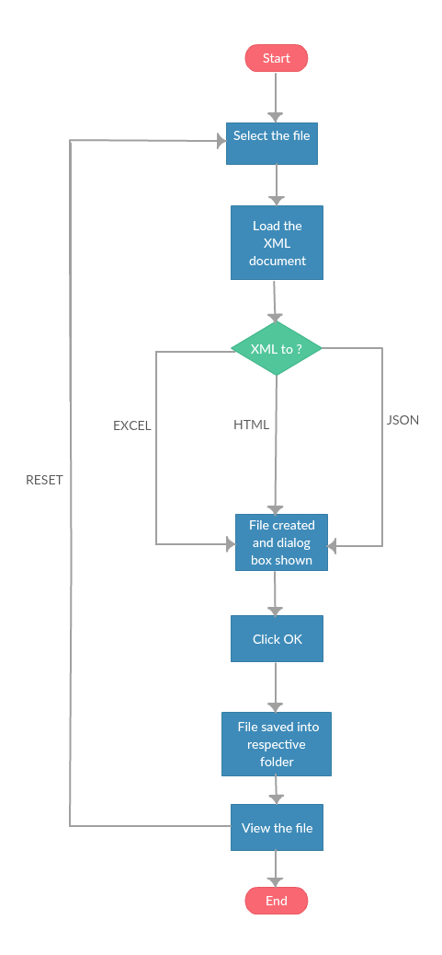

The semantic system developed begins with giving option to user to choose the XML document that need to be converted to other format. Once user selected the necessary XML document then user has to load the XML document and the values of the file would be displayed in the application. Then, user would have the option of selecting the desired output format. The available options are HTML, EXCEL, and JSON. Once user selected the desired option then the file would be created and a dialog box would pop out showing the file conversion is successful. Consequently, user has to click OK button on the dialog box and then the converted file would be saved into respective folder. After that, user can view the file converted and should user would like to convert different XML document then user can reset the existing XML document that was loaded into the application in order to select a different XML document. Or else, user can opt to end the application.

**DEMONSTRATION**

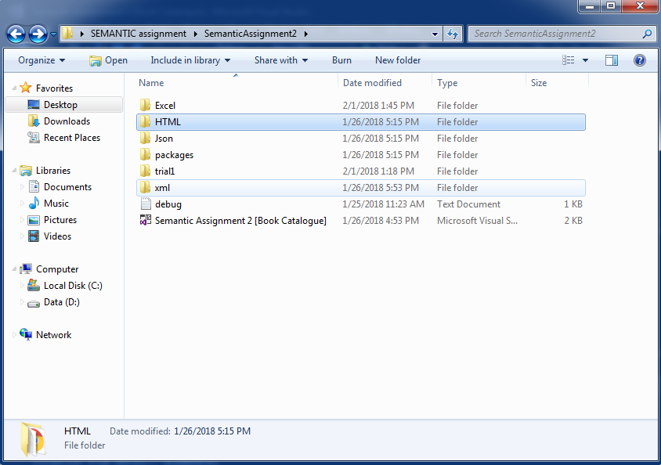 **Figure 1: Content of the main application folder**

**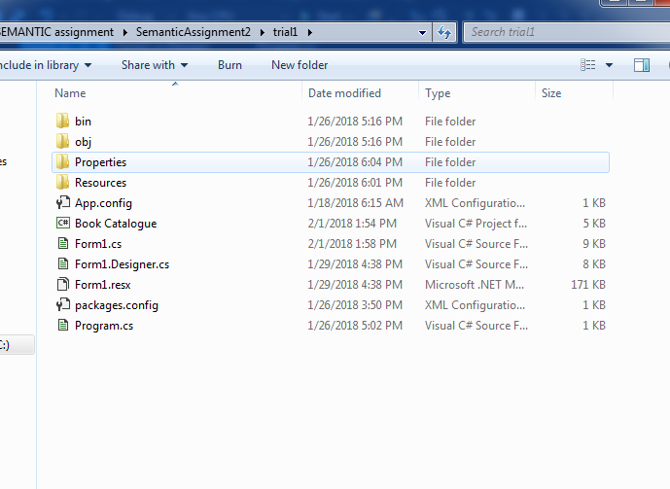  
 Figure 2: Content of the application folder (trial 1)**

**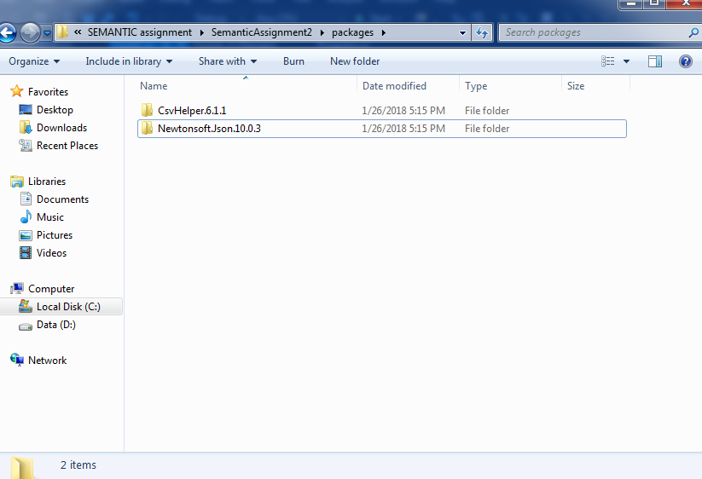  
 Figure 3: Packages used with the application**

**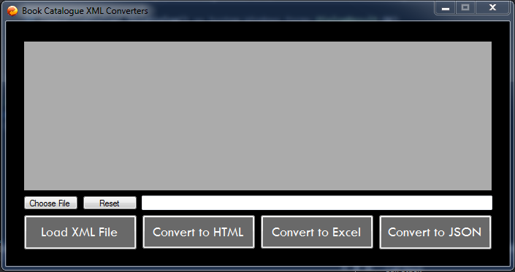  
 Figure 4: Main Menu**

**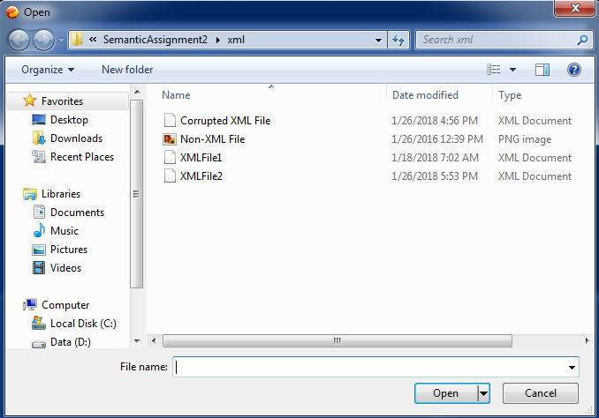  
 Figure 5: Result of clicking on “Choose File”**

**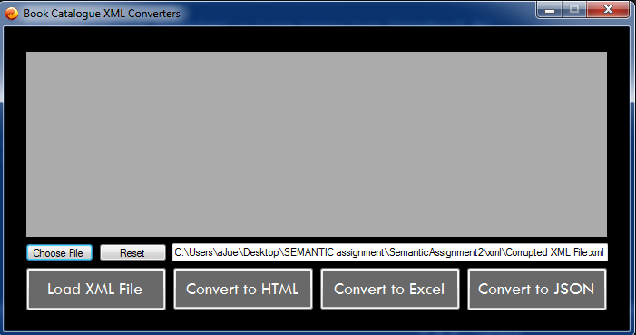  
 Figure 6: Chosen file path**

**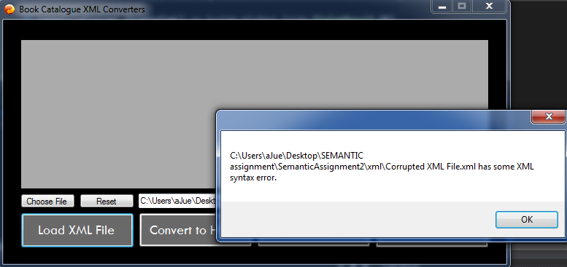  
 Figure 7: Error display on corrupted XML file**

**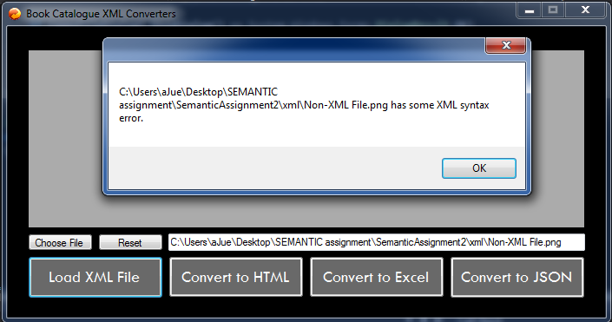  
 Figure 8: Error display on Non-XML file**

**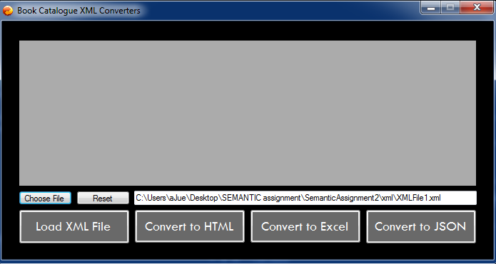  
 Figure 9: Path of the correct XML file chosen**

**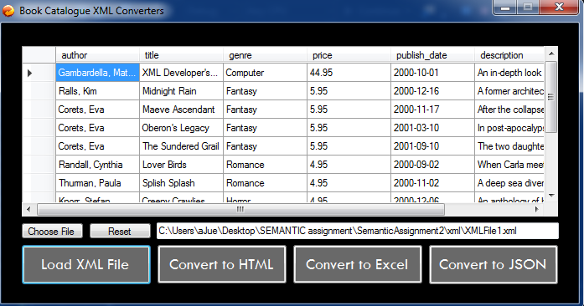  
 Figure 10: Result of loading the XML file**

**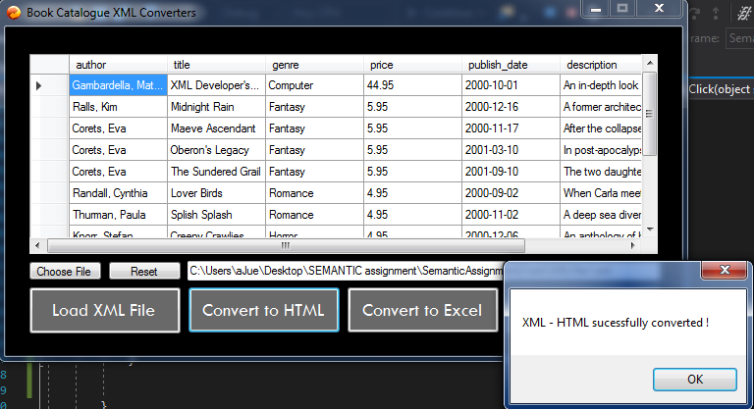  
 Figure 11: Dialog box informing on successful conversion to HTML**

**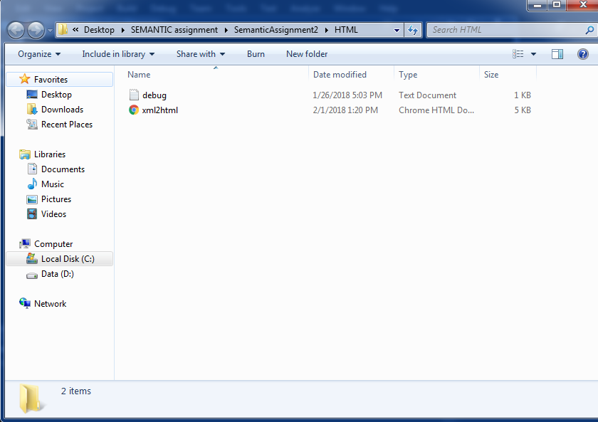  
 Figure 12: Folder of the output of HTML file**

**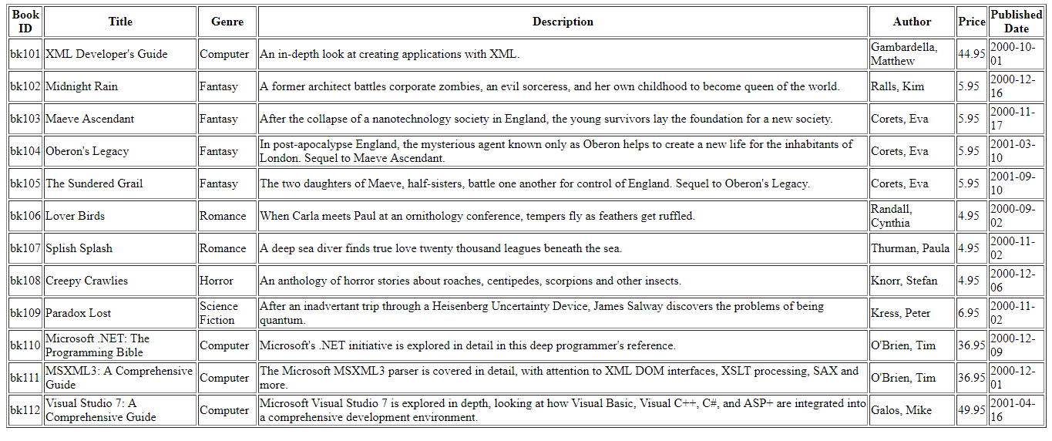  
 Figure 13: Output of HTML file**

**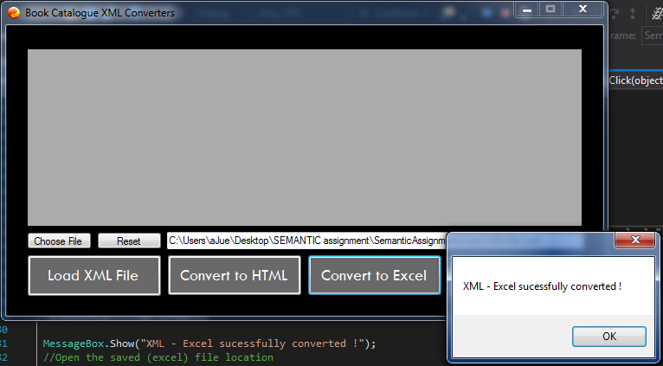  
 Figure 14: Dialog box informing on successful conversion to HTML**

**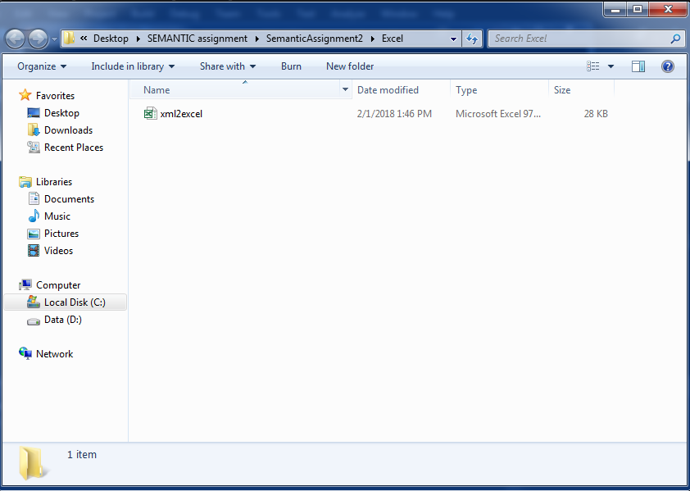  
 Figure 15: Folder of the output of EXCEL file**

**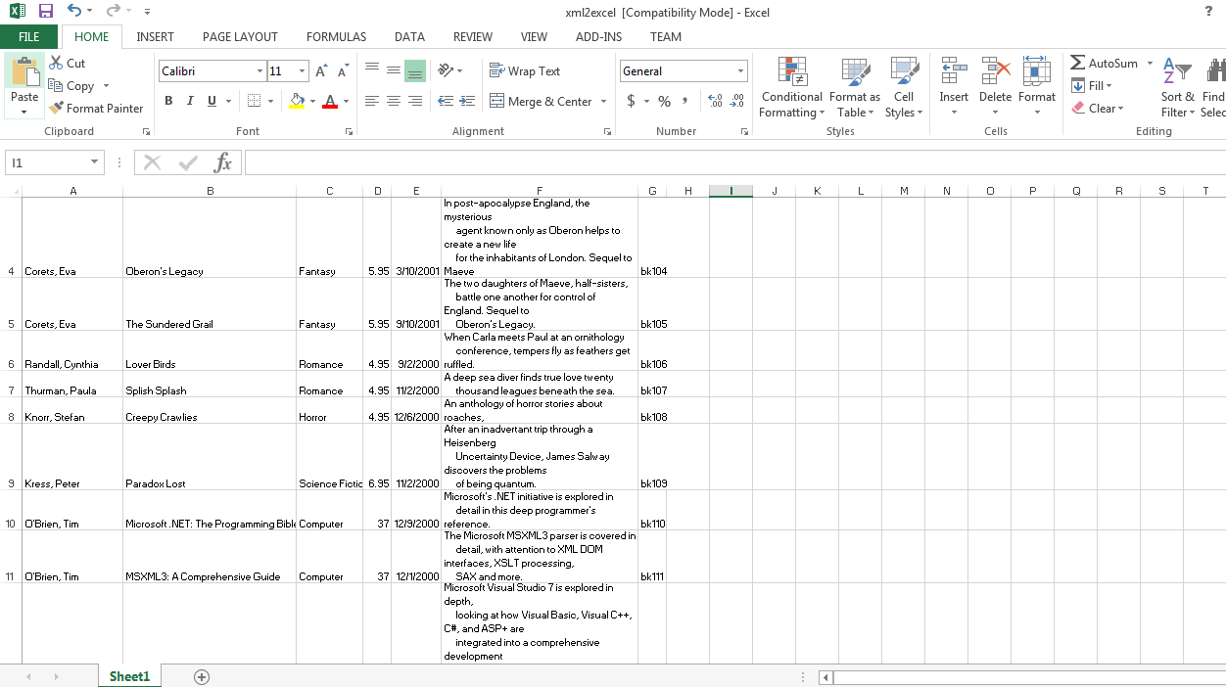  
 Figure 16: Output of EXCEL file**

**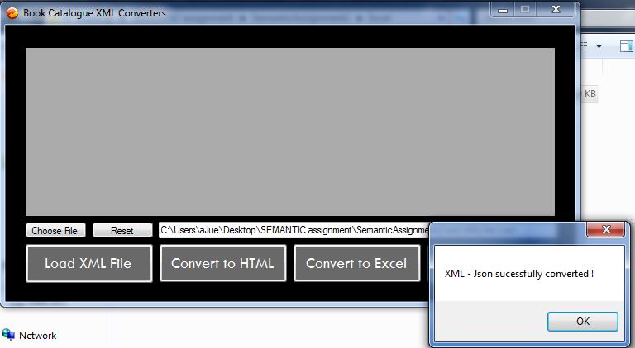  
 Figure 17: Dialog box informing on successful conversion to JSON**

**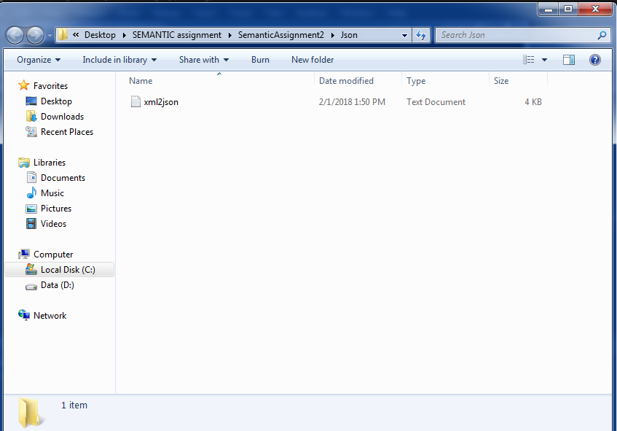  
 Figure 18: Folder of the output of JSON format**

**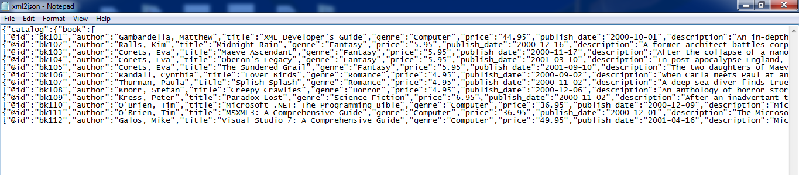  
 Figure 19: Output of JSON format**

**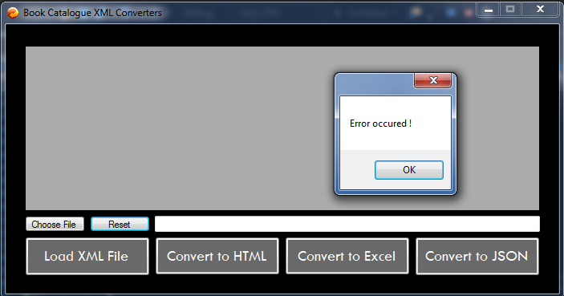  
 Figure 20: Error showed when reset button clicked without choosing any file**

**REFERENCES**

1. <http://www.c-sharpcorner.com/forums/how-to-convert-html-file-to-xml-file-using-c-sharp>
2. <https://www.codeproject.com/Questions/278449/How-to-convert-XML-to-Html-in-csharp>
3. <http://www.c-sharpcorner.com/forums/how-to-convert-html-file-to-xml-file-using-c-sharp>
4. <https://www.codeproject.com/Articles/23895/xml-to-json>
5. <https://social.msdn.microsoft.com/Forums/en-US/824374d0-a1a2-4edf-a09f-b0c34eaae180/how-to-convert-string-xml-to-json-in-c?forum=xmlandnetfx>
6. <http://csharp.net-informations.com/xml/excel-from-xml.htm>
7. <https://www.codeproject.com/Questions/420926/Convert-XML-file-to-Excel>
8. <https://en.wikipedia.org/wiki/XML>
9. <https://docs.parasoft.com/display/SOAVIRT9103/XML+Converter>